MANDATORY DISCLOSURES

- NAME OF THE INSTITUTION

SHADAN WOMENS’ COLLEGE OF PHARMACY
#6-2-980 Rajbhavan road, Khairatabad, Hyderabad,
Andhra Pradesh. PIN: 500004
Phone: 040-23305545
Fax: 040-66669915
WebSite: www.shadanwomenspharma.com,
Email id: swcp.info@gmail.com
- NAME & ADDRESS OF THE DIRECTOR
Mrs Dr. Madda Sunitha M.Pharm, Ph.D
SHADAN WOMEN’S COLLEGE OF PHARMACY
6-2-980, RAJBHAVAN ROAD
KHAIRATABAD, HYDERABAD. PIN.500004.
Phone: 040-23305545(O) 040-27617032® Mobile : 9848308324
Fax: 040-66669915
Website: www.shadanwomenspharma.com,
Email id: swcp.info@gmail.com

- NAME OF THE AFFILIATING UNIVERSITY
JAWAHARLAL NEHRU TECHNOLOGICAL UNIVERSITY,
KUKATAPALLY, HYDERABAD.

- GOVERNANCE BOARD MEMBERS

GOVERNING COUNCIL MEMBERS OF SHADAN EDUCATIONAL SOCIETY

Dr.MOHD VIZARATH RASOOL KHAN | Founder and Chief Promoter  Former M.L.A.
Dr. M.KARIMULLAH KHAN  Former Engineer-in-chief | Chairman
Mr. AZAZ-UR RAHMAN M.Tech. BITS Pilani | Vice-Chairman
Smt.SHADAN TEHNIATH  (D/o Late Abdul Khayyum, Engineer-in-chief, Govt. of A.P.  And Founder of Jawaharlal Nehru Polytechnic) | Secretary
Mr.Dr.M.MADHAVI LATHA  Assoc.Professor.ECE  COLLEGEOF ENGINEERING  JNT University, KUKATAPALLY  HYDERABAD-500072. | University Nominee

ACADEMIC ADVISORY BOARD MEMBERS

Dr.MOHD VIZARATH RASOOL KHAN | Founder and Chief Promoter  Former M.L.A.
Mr.Dr.M.MADHAVI LATHA  Assoc. Professor.ECE  COLLEGE OF ENGINEERING  JNT University,KUKATAPALLY  HYDERABAD-500072. | University Nominee
Dr.B.K.Gupta | Principal
Mrs.S. NAAZNEEN | Asst. Professor

Frequency of the Board Meetings and Academic Advisory Body

Meetings will be held three times per year to discuss various problems regarding Academic matters and others and measures to overcome them.

Student Feedback

Meetings of Faculty with student’s atleast once in every semester for good Governance, Students. Feedback and Grievance redressal.

- PROGRAMMES COURSES OFFERED:

The B.Pharmacy degree - 4 years duration, the I year being yearly and II, III & IV years are run by semester system. The intake in the first year is 100 students & intake in the 2nd year is 6 seats for Lateral entry students who can directly take admission in 2nd year.
The M. Pharmacy degree-2 years duration, I & II years are run by semester system. M.Pharm 4 Courses are there, Pharmaceutics-24 seats, Pharmacology-18 seats, Pharmaceutical Analysis & Quality Assurance-18 and Pharmaceutical Management & regulatory Affairs-18 seats

MODE OF ADMISSION: ADMISSION PROCEDURE:

The eligibility criteria for the admission into the B.Pharmacy course is a pass in intermediate, qualifying in the examination conducted by the state government (EAMCET) and qualifying the examination conducted by the management of the college. Diploma in Pharmacy (D.Pharm) students is eligible to join the course in the II year (lateral entry). If they qualify in the ECET examination conducted by the state government, 10% of t he total number of seats are reserved for this category.
FEE:

B.Pharmacy: The general fee is Rs.32000/- per year and for the management seats the fee is Rs.92000/- yearly.
M.Pharmacy: The general fee is Rs.1,10,000/- per year.

PLACEMENT FACILITIES:

Students are choosing the pharmaceutical Industries where they have taking the practical training during their academic program and many of them are pursuing their higher studies and working inside and outside the country. Students are getting Jobs through JobsChronicle.com and other companies.

- FACULTY MEMBERS:

S.No | Name of the faculty | Designation | Qualification | Photos
1. | Mrs Dr. M Sunitha | Principal | M.Pharm, PhD
2. | Mrs Dr. Nishat Fatima | Vice Principal | M.Pharm, PhD | 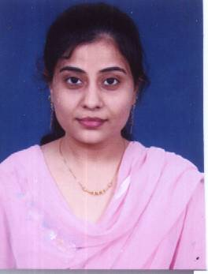
3. | MrsDr. K.Geetha | Assoc. professor | M.Pharm, PhD  Pharmacognosy | 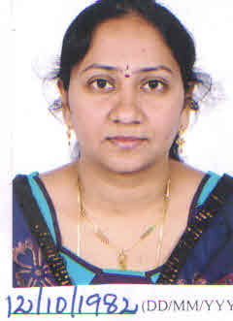
4. | Mrs P. Sandhya | Asst professor | M.Pharm, (PhD)  Pharmaceutics | 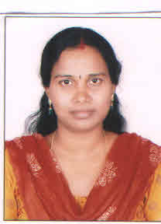
5. | Mrs Seema Bhattad | Assoc.  professor | M.Pharm  Quality Assuarance | 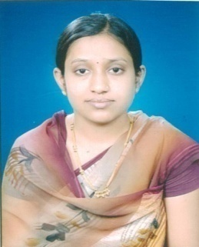
6. | Mrs.V Asha Jyothi | Asst professor | M.Pharma, (PhD)  Pharmacology | 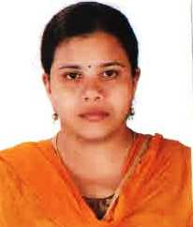
7. | Mrs. Mehnoor Farheen | Asst professor | M.Pharma, (PhD)  Pharmacology | 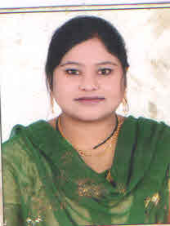
8. | Mrs Syeda Habeeba Humera | Asst Professor | M.Pharm  Pharmaceutical Chemistry | 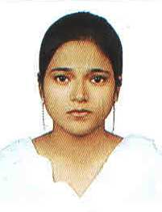
9. | Ms. K Ayesha Begum | Asst Professor | M.Pharm  Pharmaceutical Analysis & quality assurance | 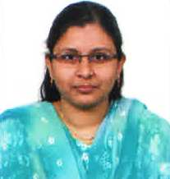
10. | Ms. Saleha Sultana | Asst Professor | M.Pharm  Pharmacology | 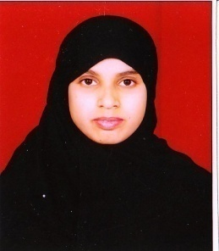
11. | Ms Humera Reshma | Asst professor | M.Pharm  Pharmaceutical Analysis & quality assurance | 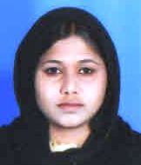
12 | Mrs Asfia Shabeer | Asst professor | M.Pharm Pharmaceutics | 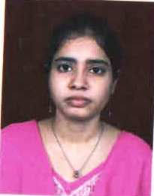
13 | Mrs Ruheena Tabassum | Asst professor | M.Pharm  Biotechnology | 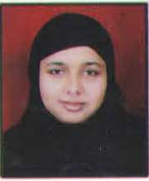
14 | Mrs Fouzia Ansari | Asst professor | M.Pharm Pharmaceutics | 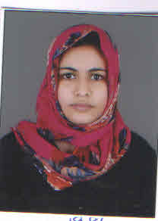
15 | Ms.Farhat  Unnisa | Asst professor | M.Pharm  Pharmaceutical Analysis & quality assurance | 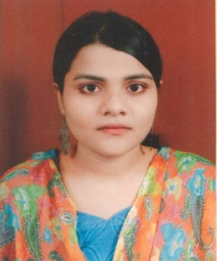
16 | Ms Hoor fatima | Asst Professor | M.Pharm  Pharmacology | 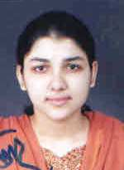
17 | Ms Farha Naaz | Asst Professor | M.Pharm  Pharmaceutical Chemistry | 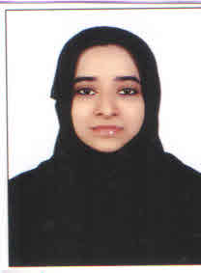
18 | Ms Bushra Anjum | Asst professor | M.Pharm Pharmaceutics | 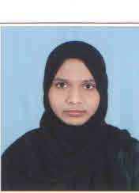
19 | Mrs Bhagya Buela. G | Asst professor | M.Pharm Pharmaceutics
20 | Mrs Heena Farheen | Asst professor | M.Pharm  Pharmaceutical Analysis & quality assurance | 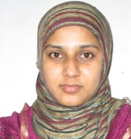
21 | Ms Ayesha Fatima Firdous | Asst professor | M.Pharm Pharmaceutics | 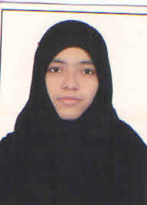
22 | Ms Ayesha Khan | Asst Professor | M.Pharm  Pharmacology | 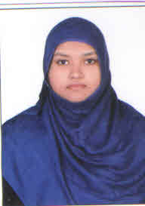
23 | Mr.Mohd Sayeed | Asst professor | MSc, ICWA Computers | 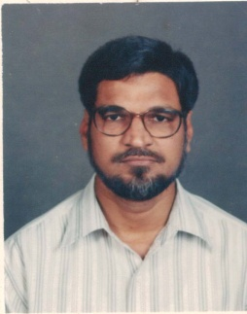
24 | S. A. Muneem | Asst professor | M.Sc, M.phil | 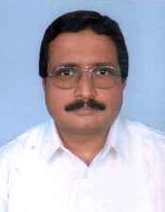

BRANCH WISE LIST OF FACULTY MEMBERS

Department / Division | Name of the post | For strength of 60 students | Provided by the institution
Department of Pharmaceutics | Professor | 1 | 1
 | Asst. Professor | 1 | 6
 | Lecturer | 2 | -
Department of Pharmaceutical Chemistry  (Including Pharmaceutical Analysis) | Professor | 1 | -
 | Asst. Professor | 1 | 2
 | Lecturer | 3 | -
Department of Pharmacology | Professor | 1 | -
 | Asst. Professor | 1 | 5
 | Lecturer | 2 | -
Department of Pharmacognosy | Professor | 1 | -
 | Asst. Professor | 1 | 1
 | Lecturer | 1 | -
Department of Pharmaceutical Biotechnology | Professor | 1 | 1
 | Asst. Professor | 1 | 1
 | Lecturer | 1 | -

PERMANENT FACULTY: STUDENT RATIO 1 : 16

7. PROFILE OF PRINCIPAL

Name: Mrs Dr. Madda Sunitha  Educational Qualification: M.Pharm. Ph.D  Teaching Experience : 11 Years 06 Months  Industrial Experience :  Research Experience :3 years  Research Publications &  No. of Papers Published: International Journals: 15 Nos. & National Journals: 15 Nos, 17 publication | 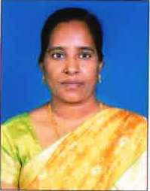

8. FEE:
The general fee is Rs.32000/- per year and for the management seats the fee is Rs.92000/- yearlyfor b.pharmacy & Rs. 1,10,000/- per year for M.Pharmacy. Fee has to be paid two to three weeks before commencement of Classes. For I/IV B.Pharm fee has to be paid during first or second week of October every year and for II/IV, III/IV, IV/IV B.Pharm fee has to be paid in the last week of June every year.
Year of Approval | No. of Seats Sanctioned
1997-98 | 40
1998-99 | 40
1999-00 | 40
2000-01 | 40
2001-02 | 60
2002-03 | 60
2003-04 | 60
2004-05 | 60
2005-06 | 60
2006-07 | 60
2007-08 | 60
2008-09 | 60
2009-10 | 60
2010-11 | 100
2011-12 | 100
2012-13 | 100
2013-14 | 100
2014-15 | 100
9.ADMISSION

The eligibility criteria for the admission into the B.Pharmacy course is a pass in intermediate, qualifying in the examination conducted by the state government (EAMCET). Diploma in Pharmacy (D.Pharm) students is eligible to join the course in the II year (lateral entry). If they qualify in the ECET examination conducted by the state government, 10% of t he total numbers of seats are reserved for this category.
No.of students admitted in the first year is 100 and students admitted in the second year is 100 (6 Lateral entry). No. of students admitted under Management quota are 30 and the students admitted under Convener quota are 70.

10. ADMISSION PROCEDURE

EAMCET conducted by Jawaharlal Nehru Technological University, Kukatpally, Hyderabad.
Last date for request or submission of applications is April every year.
Final results are announced in the month of May.

11. INFORMATION ON INFRASTRUCTURE AND OTHER RESOURCES AVAILABLE

LIBRARY:

The college had a well-developed library which can accommodate more than 100 students at a time and Internet facility is being provided.

Total number of Titles of Books : 600
Total number of volume of Books : 2103
No.of National Journals : 15
No.of International Journals : 15

Subject wise Classification of books available

Sl. No | Subject | Available
 |  | Titles | Numbers
1 | Pharmacy Practice | 50 | 166
2 | Human Anatomy & Physiology | 70 | 419
3 | Pharmaceutics (Dispensing & General Pharmacy) | 45 | 203
4 | Pharmacognosy | 35 | 187
5 | Pharmaceutical Organic Chemistry | 20 | 75
6 | Pharmaceutical Inorganic Chemistry | 25 | 109
7 | Pharmaceutical microbiology | 20 | 44
8 | Pathophysiology | 25 | 82
9 | Applied Biochemistry & Clinical Chemistry | 55 | 136
10 | Pharmacology | 25 | 44
11 | Pharmaceutical Jurisprudence | 15 | 15
12 | Pharmaceutical Dosage Forms | 15 | 15
13. | Community Pharmacy | 15 | 16
14. | Clinical Pharmacy | 10 | 20
15. | Hospital Pharmacy | 15 | 47
16. | Pharmacotherapeutics | 25 | 20
17. | Pharmaceutical analysis | 20 | 20
18. | Medicinal Chemistry | 25 | 166
19. | Biology | 10 | 22
20. | Computer Science or Computer Application in pharmacy | 20 | 52
21 | Mathematics/Statistics | 13 | 197

The college Library has the following Pharmaceutical Journals:

- PHYTOPHARMA
- PHARMABUZZ
- HERBAL TECH
- INDIAN DRUGS
- PHARMA TIMES
- INDIAN PHARMACIST
- PHARMA ASIA
- INDIAN JOURNAL OF HETROCYCLIC CHEMISTRY
- INDIAN JOURNAL OF HOSPITAL PHARMACY
- INDAIN JOURNAL OF PHARMACOLOGY
- INDIAN JOURNAL OF PHARMACEUTICAL SCIENCE
- INDAIN JOURNAL OF PHARMACEUTICAL EDUCATION AND RESEARCH
- INDIAN JOURNAL OF BIOTECHNOLOGY
- INDIAN JOURNAL OF PHARMACEUTICAL RESEACH
- SCIENCE REPORTER
- PHAMACOGNOSY MAGAZINE
- INDIAN JOURNAL OF TRADITIONAL KNOWLEDGE
- NATURAL PRODUCT RADIANCE
LABORATORIES:

S.No | Name of the Laboratory | Plinth Area (Sq. M) | Major Facilities
1. | Pharmacognosy | 81.64 | Fully ventilate, spacious with water and gas supply
2. | Biochemistry | 81.64 | ‘’
3. | Microbiology | 95.63 | “
4. | Instrumentation | 81.64 | “
5. | A.P.H.E | 81.64 | “
6. | Pharmachemistry-1 | 81.64 | “
7. | Balance room | 41.26 | “
8. | Pharmachemistry-II | 81.64 | “
9. | Pharmacology | 81.64 | “
10. | Pharmaceutices | 81.64 | “
11. | Pharmacutical Technology | 81.64 | “
12. | Machine room | 95.63 | “
13 | Computers | 95.63 | “

In addition to the above 10 laboratories we have Instrumentation room and Machine room and Balance room as well. The college had a well developed animal house for carrying on Pharmacological experiments and developing Medicinal Plant garden on the terrace with about 90-100 medicinal plants.

EQUIPMENTS:

SL.No | Name of the Equipment & Machinery | No. Available | PCI Requirement
1. | Continuous hot extraction | 5 | 5
2. | Conical Percolator | 20 | 20
3. | Tincture Press | 1 | 1
4. | Grinding Mill | 5 | 5
5. | Disintegrator | 1 | 1
6. | Ball Mill | 1 | 1
7. | Hand operated tablet machines | 3 | 3
8. | Tablet coating pan unit with hot air blower (LABORATORY SIZE) | 1 | 1
9. | Polishing Pan (LABORATORY SIZE) | 1 | 1
10. | Tablet Hardness Tester(Monsanto Type) | 3 | 3
11. | Tablet Hardness Tester (Pfizer Type) | 3 | 3
12. | Distegration Test Unit | 3 | 2
13. | Dissolution rate test APPARATUS | 3 | 1
14. | Granulating Sieve Set | 20 | 20
15. | Tablet Counter (small size) | 5 | 5
16. | Friability Tester | 1 | 1
17. | Collapsible tube filling & sealing equipment | 3 | 2
18. | Capsule Filling & sealing equipment | 2 | 2
19 | Prescription Balance |  | 40
20 | Balance Torsion type with removable glass pen sensitivity 30 gm | 5 | 5
21 | Distallation equipment (for distilled water) | 4 | 4
22. | Water Deinoinzation Unite | 1 | 1
23. | All Glass distillation unit (for making water for injection) | 2 | 2
24. | Ampolue Washing Machine | 1 | 1
25. | Ampoule filing & sealing machine | 1 | 1
26. | Sintered glass filters for bacteria proof filtration (4 different grades) | 80 | 80
27. | Millipore filter (3 grades)2 of each G ade | 6 | 6
28 | Autoclaves | 2 | 2
29. | Pressure Cooker | 5
30. | Hot air Sterilizer | 3 | 2
31. | Incubator | 2 | 2
32. | Aseptic Cabinet | 2 | 2
33. | Rabbit cage and holder | 10 | 10
34. | Ampoule clarity test equipment | 2 | 2
35. | Blender | 2 | 2
36. | Sieves Set (pharmacopeoeial stds) | 10 | 10
37. | Laboratory Centrifuges | 4 | 2
38. | Ointment Slab u |  | 40
39. | Ointment Spatula | 40 | 40
40. | Pestle & Mortar (porcelain) |  | 40
41. | Pestle & Mortar (Glass) | 10 | 10
42. | Suppositary Mould of 3 sizes | 60 | 60
43. | Refrigerator | 3 | 1
44 | Polarimeter | 2 | 1
45. | Refractormeter | 2 | 1
46. | Photoelectric Colormeter | 3 | 1
47. | PH meters | 3 | 2
48. | Automic model Set | 10 | 10
49. | Analytical balance & weight box sets | 10 | 10
50. | Physical balance & weight box sets | 5 | 5
51. | Platform balance | 2 | 2
52. | Periodic table chart | 2 | 2
53. | Haemoglobinometer | 20 | 20
54. | Haemocytometer | 10 | 10
55 | Students organ bath | 5 | `5
56. | Sherrington rotating drum | 5 | 5
57. | Frog writing lever | 15 | 15
58. | Dissecting Tray | 10 | 10
59. | Forntal writing lever | 15 | 15
60 | Tele therometer | 1 | 1
61. | Aeration tube | 20 | 20
62. | Pole climbing apparatus | 1 | 1
63. | Histamine Chamber | 1 | 1
64. | Simple lever | 15 | 15
65. | Starling heart lever | 10 | 10
66 | EGG Machine
67. | Aerator | 5 | 5
68. | Histological slides |  | 25
69. | Sphygmomanometer | 5 | 5
70. | Stethoscope | 5 | 5
71 | First aid equipment | 5 sets | 5 sets
72. | Contraceptive device | 5 sets | 5 sets
73 | Dissecting instruments | 20 sets | 20 sets
74. | Operation table (small) | 2 | 2
75. | Balancing for weighing small animals | 1 | 1
76. | Kymograph paper | Adequate | Adequate
77. | Activity Cage (Actophotometer) | 1 | 1
78. | Analgesiometer | 1 | 1
79. | Thermometer | 20 | 20
80. | Plastic animal cage | 10 | 10
81. | Double unit organ bath thermostat | 1 | 1
82. | Single Pan balance | 1 | 1
83. | Physiology & Pharmacology charts | Adequate | Adequate
84. | Human Seleton | 1 | 1
85. | Antomical Specimen | 1 set | 1 set
86. | Electro-Convulsiometer | 1 | 1
87. | Stop watch | 10 | 10
88. | Camp, Bossheads, Screw clips | Adequate | Adequate
89. | Symes Cannula | 20 | 20
90. | Compound Microscope | 60 | 60
91. | Watch glass | 25 | 25
92. | Membrane filter
93. | Microscope with oil immersion | 6
94 | Pharmacolgnosy Charts | Adequate | 100
95. | Pharmacognosy models |  | 50
96. | Permanent Slides |  | 100
97. | Mixing vat with stirrer | 2 | 2
98. | Filtration equipment | 2 | 2
99. | Laminar aire flow bench | 1 | 1
100. | Vacuum pump | 3 | 3
101. | Surgical dressing | 2 | 2
102. | Karl Fischer apparatus | 1 | 1
103. | Flame Photometer | 1 | 1
104. | Magnetic stirrer | 1 | 1
105. | Thermostatic bath | 1 | 1
106. | Experimental animals | Adequate | Adequate
107 | General glassware | Adequate | Adequate
108 | Chemicals, appliances & Lab facilities | Adequate | Adequate
109 | Overhead Projector | 1 | 1
110. | Slide cum strip Projector | 1 | 1
111. | Projection Screen | 1 | 1
112. | Centrifligues | 3 | 3
113. | Colometers | 2 | 2

COMPUTER LAB

The college is having a separate Computer lab with 80 Computers with LAN/WAN facility.

Number and Configuration of Systems : PIV 2.8Hz
Total number of systems connected by LAN/WAN : 80
Internet bandwidth : 1Mbps
Major software packages available : Windows, MS office, C, C++

WORKSHOP

Number of Classrooms and size of each : 6 & each 81.65 sq.m
Number of Laboratories and size of each : 10 & each 81.64 sq.m
Number of Drawing halls and size of each : 1 & each 81.65 sq.m
Number of Computer centre and size of each : 1 & each 81.65 sq.m

CENTRAL EXAMINATION BRANCH:

EDEP Examination pattern as prescribed by JNT University is being with all the required facilities placed in the Principal’s room in a very confidential manner. Examination branch consists of 4 Staff members along with Chief Superintendent. Internet facility is provided for 4 Computers and 3 Printers.
Teaching Load of each Faculty: 16-18 hours per week.

For Academic Calendar Please click here

SHADAN WOMEN’S COLLEGE OF PHARMACY
IV/ IV B.PHARMACY I SEMESTER: TIME TABLE (2014-2015)
R 09 REGULATION
Hall-I

DAY | 7:30-10:00 am | 10:15-11:10 am | 11:10-12:05 pm | 12:05-1:00 pm | 1:00-1:55 pm
MONDAY | Ph. Analysis II B-I  BioPharmaceutics B-II | Ph. Analysis II | PIM | Med. Chem II | Pharmacology-III
TUESDAY | BioPharmaceutics B-I  Ph. Analysis II B-II | BioPharmaceutics | Pharmacology III | Ph. Analysis II | PIM
WEDNESDAY | Med. Chem B-I  Pharmacology B-II | Pharmacology III | Med. Chem II | BioPharmaceutics | Ph. Analysis II
THURSDAY | Pharmacology B-I  Med. Chem B-II | PIM | BioPharmaceutics | Med. Chem II  (Seminar) | Pharmacology III
FRIDAY | PIM  (7:30-8:30am) | Ph. Analysis II  (8:30 – 9:30 am) | Pharmacology III  (9:30-10:30) | Biopharmaceutics  (10:45 – 11:45 am) | Med. Chem II  (11:45-12:45pm)
SATURDAY | Med. Chem II | Ph.Analysis II | BioPharmaceutics | PIM | Pharmacology III
Break Timings: 10:00-10:15 am

STAFF:

Ph. Analysis II -------- Farhath Unnisa / Anitha

Biopharmaceutics------- Asfia / Farzana

Medicinal Chemistry----------- Heena Farheen / Naseem

PharmacologyIII--------Saleha Sultana/ Hafeez Khan

Pharmacy Administration-----------K Ayesha Begum

Incharge: Saleha Sultana

SHADAN WOMEN’S COLLEGE OF PHARMACY
IV/ IV B.PHARMACY I SEMESTER: TIME TABLE (2014-2015)
R 09 REGULATION
Hall-II

DAY | 7:30-10:00 am | 10:15-11:10 am | 11:10-12:05 pm | 12:05-1:00 pm | 1:00-1:55 pm
MONDAY | Med. Chem B-I  Pharmacology B-II | Ph. Analysis II | PIM | Med. Chem II | Pharmacology-III
TUESDAY | Pharmacology B-I  Med. Chem B-II | BioPharmaceutics | Pharmacology III | Ph. Analysis II | PIM
WEDNESDAY | Ph. Analysis II B-I  BioPharmaceutics B-II | Pharmacology III | Med. Chem II | BioPharmaceutics | Ph. Analysis II
THURSDAY | BioPharmaceutics B-I  Ph. Analysis II B-II | PIM | BioPharmaceutics | Med. Chem II  (Seminar) | Pharmacology III
FRIDAY | PIM  (7:30-8:30am) | Ph. Analysis II  (8:30 – 9:30 am) | Pharmacology III  (9:30-10:30) | Biopharmaceutics  (10:45 – 11:45 am) | Med. Chem II  (11:45-12:45pm)
SATURDAY | Med. Chem II | Ph.Analysis II | BioPharmaceutics | PIM | Pharmacology III
Break Timings: 10:00-10:15 am

STAFF:

Ph. Analysis II -------- Humera Reshma / Anitha

Biopharmaceutics------- Bushra / Farzana

Medicinal Chemistry----------- Farha Naaz / Naseem

PharmacologyIII--------Mehnoor farheen/ Hafeez Khan

Pharmacy Administration----------- V.Asha Jyothi

Incharge: Mehnoor Farheen

SHADAN WOMEN’S COLLEGE OF PHARMACY

III/ IV B.PHARMACY I SEMESTER: TIME TABLE (2014-2015)

R 09 REGULATION

DAY | 7:30-8:20 am | 8:20-9:10 am | 9:10-10:00 am | 10:00-10:50 am | 11:00-1:30 pm
MONDAY | Ph. Technology I | Microbiology | Biochemistry | Pharmacology I | Biochemistry B-I  Microbiology B-II  Pharmacognosy B-III
TUESDAY | Ph. Technology I | Pharmacognosy II | Biochemistry | Pharmacology I | Biochemistry B-II  Microbiology B-III  Technology B-I
WEDNESDAY | Microbiology | Biochemistry | Pharmacology I | Pharmacognosy II | Biochemistry B-III  Pharmacognosy B-I  Technology B-II
THURSDAY | Ph. Technology I | Pharmacognosy II | Microbiology | Pharmacology I | Microbiology B-I  Pharmacognosy B-II  Technology B-III
FRIDAY | Pharmacology I  (7:30-8:30) | Biochemistry  (8:30-9:30) | Microbiology  (9:30-10:30) | Ph. Technology I  (10:30-11:30) | Pharmacognosy II  (11:30-12:30)
SATURDAY | Pharmacognosy II | Biochemistry | Ph. Technology I | Microbiology | Pharmacology I

Break Timings: 10:50-11:00 am

STAFF:

Biochemistry -------- Ayesha fatima / Shaheen

Microbiology ------ Ruheena/ Zainab

Pharmacognosy II -------- K. Geetha / Anitha

Pharmacology I ------- Hoor Fatima.

Ph. Technology I ----------- Seema (Ph. Technology I Lab…….. Bhagya Buela / Farzana)

Incharge: Hoor Fatima

SHADAN WOMEN’S COLLEGE OF PHARMACY

II/ IV B.PHARMACY I SEMESTER: TIME TABLE (2014-2015)

R 13 REGULATION

DAY | 7:30-8:20 am | 8:20-9:10 am | 9:10-10:00 am | 10:00-10:50 am | 11:00-1:30 pm
MONDAY | Health education & Pathophysiology | Organic chemistry | Statistical Methods and Computer Education | Physical Pharmacy | Computer Education B-I  Organic Chemistry B-II  Physical pharmacy B-III
TUESDAY | Unit Operations | Physical Pharmacy | Organic chemistry | Health education & Pathophysiology | Organic Chemistry B-I  Physical Pharmacy B-II  APHE B-III
WEDNESDAY | Organic chemistry | Health education & Pathophysiology | Unit Operations | Physical Pharmacy | Physical Pharmacy B-I  APHE B-II  Computer Education B-III
THURSDAY | Physical Pharmacy | Health education & Pathophysiology | Organic chemistry | Unit Operations | APHE B-I  Computer Education B-II  Organic chemistry B-III
FRIDAY | Statistical Methods and Computer Education (8:30-9:30) | Physical Pharmacy (9:30-10:30) | Unit Operations  (10:30-11:30) | Pharmacognosy II  (11:30-12:30) | Statistical Methods and Computer Education  (7:30-8:30)
SATURDAY | Organic Chemistry-II | Statistical Methods and Computer Education | Physical Pharmacy I | Health education & Pathophysiology | Unit Operations-I

Break Timings: 10:50-11:00 am

STAFF:
Statistical Methods and Computer Education -------- Md. Sayeed

Physical Pharmacy I ------ Fouzia Ansari /Farzana

Organic Chemistry-II ----- Syeda Habeeba Humera /Zeenath

Unit Operations-I -------- Bhagya Buela / Zainab

Health education & Pathophysiology ------- Ayesha Khan /Hafeez khan

Incharge: Bhagya Buela

